Early Years Overview
2022-2023
 | Autumn 1 | Autumn 2 | Spring 1 | Spring 2 | Summer 1 | Summer 2
Daycare | Who am I? | What does it feel like? | How do I feel today? | Who can help me? | What does water do? | What’s that sound?
Nursery | Who am I? | What does it feel like? | How do I feel today? | Who can help me? | What does water do? | What’s that sound?
Reception | Unity around the World | Woodland animals and minibeasts | Space | British birds | Growing | On the Farm
Reception Curriculum Overview 2022-23

Communication and Language | Our big question:  Who are we? | Our big question:  Who lives in the woods? | Our big question:  Where will I go? | Our big question:  What do I see? | Our big question:  What’s in the ground? | Our big question:  Where does it come from?
Personal, Social and Emotional Development | - See themselves as a valuable individual.  - Build constructive and respectful relationships.  - Express their feelings and consider the feelings of others  - Show resilience and perseverance in the face of challenge.  - Identify and moderate their own feelings socially and emotionally.  - Think about the perspectives of others. |  |  | - See themselves as a valuable individual.  - Build constructive and respectful relationships.  - Express their feelings and consider the feelings of others  - Show resilience and perseverance in the face of challenge.  - Identify and moderate their own feelings socially and emotionally.  - Think about the perspectives of others.
 |  |  | Focus on Oral hygiene – visit from school dental nurse
Physical Development | - Independently get dressed (put on a coat, zip up etc.)  - Use a comfortable pencil grip. | - Show a preference for a dominant hand.  - Use one handed tools. | Develop small motor skills so that they can use a range of tools competently, safely and confidently. Suggested tools: pencils for drawing and writing, paintbrushes, scissors, knives, forks and spoons. |  | - Most letters are correctly formed. | - Most letters are correctly formed.  - Develop foundations of a handwriting style.
 | MCFC Coaching | MCFC Coaching | MCFC Coaching | MCFC Coaching | MCFC Coaching | MCFC Coaching
Literacy | - Name writing  - Tuning in to initial sounds.  - Write Phase 2 graphemes. | - Read individual letters by saying the sounds for them.  - Blend CVC words.  - Write CVC words. | - Write a label.  - Read CVC words.  - Identify and read tricky words. | - Write a caption.  - Read simple words and phrases. | - Write a simple sentence.  - Read a sentence | - Write simple sentences.  - Read aloud simple sentences.
 | Fiction: 10 Little fingers and 10 Little Toes. | Fiction: Owl Babies | Fiction: Whatever next | Fiction: Pedro’s Walk | Fiction: The Enormous Turnip | Fiction: Farmer Duck
 | Non-Fiction: Welcome to our world | Non-Fiction: Foxes | Non-Fiction: How to get ready to play in the mud | Non-Fiction: How can I help Rory the garden bird? | Non-Fiction: Fruit kebab recipe | Non-Fiction: Farmer Diary entry
 | Poetry: 1, 2, buckle my shoe | Poetry: Leaf Man | Poetry: 5 little astronauts | Poetry: The chicken lays eggs | Poetry: A little seed | Poetry: The Cow
 | Phase 2 phonics | Phase 2 phonics | Phase 3 phonics | Phase 3 phonics | Phase 4 phonics | Phase 4 phonics
Mathematics | - Subitising to 3.  - Counting 1:1 correspondence (up to 5).  - Compare sets of objects.  - Connect quantities and number patterns to fingers.  - Hear and join in with a counting sequence to 20.  - Developing concept of cardinality. | - Subitise different arrangements within 5.  - Count objects 1:1 (up to 10).  - Spot smaller numbers ‘hiding’ inside larger numbers.  - Begin to develop the language of ‘whole’ when talking about objects which have parts. | - Count objects 1:1 beyond 10.  - Continue to develop subitising skills within and beyond 5.  - Focus on equal and unequal groups when comparing numbers.  - Begin to identify missing parts for numbers within 5. | - Count to 20.  - Orders numbers and plays track games.  - Understands that 2 equal numbers can be called ‘double’.  - Joins in with verbal counting beyond 20, hearing the repeated pattern. | - Explore a range of arrangements (using 10 frames) and introducing doubles.  - One more and one less.  - Identifies when amounts can be subitised and when they need counting. | - Explore a range of arrangements (using 10 frames) and introducing doubles.  - One more and one less.  - Identifies when amounts can be subitised and when they need counting.
Understanding the World | - Languages we speak (G)  - Countries that are special to us (G)  - Our homes and local environment (G)  - Changes in living memory – babies (H) | - Changing seasons (S)  - Hibernation (S) (G)  - Our environment vs. another. (G)  - Diwali (RE)  - Christmas (RE) | - Space (S)  - Change makers (H)  - Forces (S)  - Luna New Year (RE) | - Our environment (G)  - Recycling (S)  - Countryside, towns and cities (G) | - Changing seasons (S)  - Planting and Growing (S)  - Features of a plant (S)  - Eid (RE) | - My senses (S)  - Draw information from a simple map (G)  - Changes in farming (H)  - Daily life on the farm (S) (H)
Expressive Art and Design | - Clap out the syllables in our name (M)  - Getting to know our instruments / routines (M)  Workshop junk modelling - (DT) KAPOW  Drawing: Marvellous Marks - (A) KAPOW | Celebration music - (M) KAPOW  Seasonal crafts - (A) KAPOW  Painting and mixed media - (A) KAPOW | Exploring sound - (M) KAPOW  Workshop junk modelling - (DT) KAPOW | Music and movement - (M) KAPOW  Textiles: Bookmarks - (DT) KAPOW  Painting and mixed media - (A) KAPOW | Musical stories - (M) KAPOW  Food: Soup (DT) KAPOW  Craft and Design: Let’s go - (A) KAPOW | Big band - (M) KAPOW  Sculpture and 3D creation station - (A) KAPOW  Structures: Boats - (DT) KAPOW
Celebrations, festivals, events | Birthdays  Black History Month (Oct) | Harvest festival (Oct)  Diwali (end of Oct)  Bonfire night  Christmas  Remembrance  Hanukah (end of Nov) | New Year  Luna New Year  Number day (4/2)  Valentine’s Day  Spring | World Book Day (March)  Pancake Day  Holi (March)  St Patrick’s Day (17/3)  Mother’s day  Easter | Ramadan  Eid Al Fitr  Mental health week (May) | Pride month (June)  Fathers Day  Sumemr Solstice  Eid Al Adha
Enrichment | Walk around local area  Visits from parents/new babies | Visitors – parent for Diwali.  Minibeast hunt in forest school area.  Hedgehog visit | Staff/Parent visit for Luna New Year  Preparing toast (instruction writing)  Space dome | Parent for Holi  Looking at a nest  Bird watching  Making bird feeders  Getting our garden ready for the birds.  Easter egg hunt  Making pancakes  Visit from Mrs B’s chicken | Planting  Explore forest school area  Parent / Staff for Eid | Visit to Farm  Picnic  Transition to Y1  Visits from Y1 teachers  Baking and Cooking

Key
(G) - Geography  (H) - History  (S ) - Science  (RE) - Religious Education | (A) – Art  (DT) – Design and Technology  (M) - Music

RO Talk 4 Writing Model Texts
 | Autumn 1 | Autumn 2 | Spring 1 | Spring 2 | Summer 1 | Summer 2
Fiction | 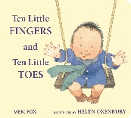 | 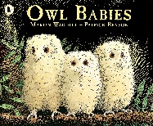 | 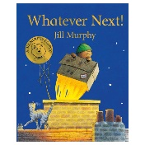 | 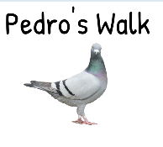 | 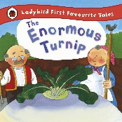 | 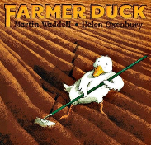
Non-Fiction | 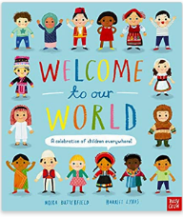 | 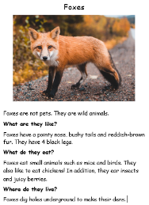 | 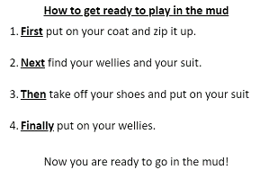 | 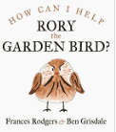 | 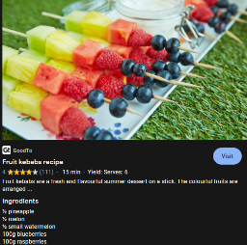 | 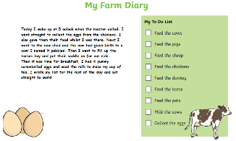
Poetry | 1, 2, Buckle my shoe  - Jane Cabrera | Leaf Man  - Lois Elhart | 5 little men in a flying saucer  – nursery rhyme | The chicken lays eggs  - Meish Goldish | A little seed  - Mabel Watts | The Cow  - Author unknown
Supporting texts | Coming to England – Floella Benjamin  Elmer - David McKee  What makes me a me? – Ben Faulks and David Tazzyman  Marvellous Me – Lisa Bullard  You choose – Pippa Goodheart  So Much! – Trish Cooke  Three Little Pigs  Houses and Homes – information text  The mega magic Hair swap – Rochelle Humes  Families – Usbourne | A home full of friends – Peter Butley  We’re going on a bear hunt – Michael Rosen  Welcome to the Woodland – Ruth Owen  The hedgehog – Nick Butterworth  The town mouse and the country mouse.  One mole digging a hole – Julia Donaldson  The Gruffalo – Julia Donaldson  Squirrels Busy Day – Lucy Barnard  Little Acorn | How to catch a star – Oliver Jeffers  Mrs Armitage on Wheels – Quentin Blake  Goodnight Moon – Margaret Wise Brown  The Way Back Home – Oliver Jeffers  Aliens love underpants – Claire Freedman  The Darkest Dark – Chris Hadfield  The Smeds and The Smoos – Julia Donaldson  Helen Sharman – Non fiction  Red Rockets and Rainbow jelly– Sue Heap | Six dinner sid – Inga Moore  My First Book of Garden Birds – RSPB  Too shy to sing – Author unkown  The Go-Away Bird – Julia Donaldson  Robins, Wrens and other British Birds – National Trust  The Dawn Chorus – Suzanne Barton  Rosie’s Walk – Pat Hutchins  Why do birds have feathers? – Wildlife wonders | Handa’s surprise – Eileen Browne  Off to the Market – Elizabeth Dale  Oliver’s vegetables – Vivian French  Vegetables – Vic Parker  A farmer’s life for me – Jan Dobbins  From a tiny seed to a mighty tree – Fundamental science  Supertato – Sue Hendra  The Runaway Pea – Kjartan Poskitt  The Pear Tree – Meredith Hooper  The Scarecrow’s wedding – Julia Donaldson | Mr Gumpy’s Outing - John Burningham  What the Ladybird heard – Julia Donaldson  You’re too small – Shen Roddie  Cockadoodle Moo – John Foster  A squash and a squeeze – Julia Donaldson  Duck in the truck – Jez Alborough  The farmer’s Away! – Anne Vittur Kennedy

